PLACEMENT COMMITTEE 2025 - 2026

PlaceCom
Consulting Toolkit
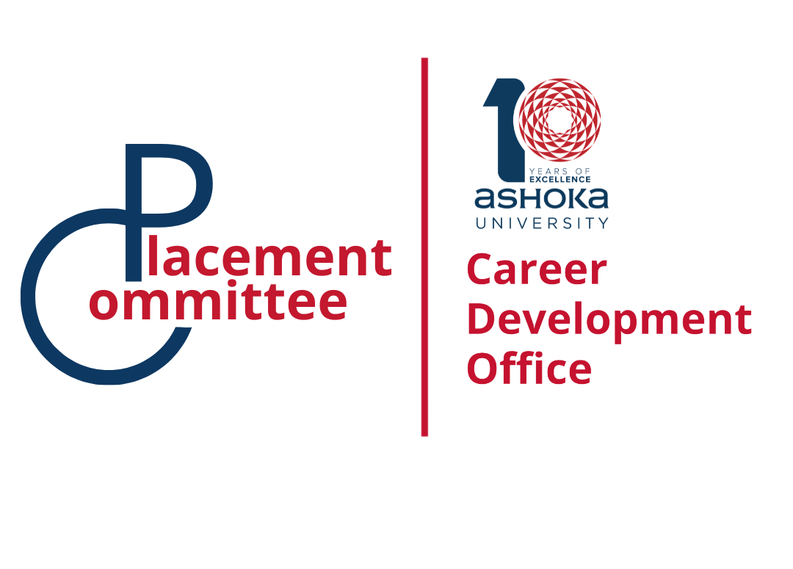

CaseInterview.com (Victor Cheng)
- URL: https://www.caseinterview.com
- Description: Comprehensive case interview preparation site by Victor Cheng, author of "Case Interview Secrets." Contains frameworks, practice cases, and step-by-step guidance for consulting interviews across all major firms.

Bridgespan Career Toolkit
- URL: https://www.bridgespan.org/about-us/careers-at-bridgespan/applicant-toolkit/preparing-for-your-consulting-interview
- Description: Specialized resource for social sector and development consulting interviews. Provides case interview preparation specifically tailored for organizations like Bridgespan, FSG, and similar mission-driven consulting firms.

Crafting Cases
- URL: https://www.craftingcases.com
- Description: Consulting case interview preparation platform offering structured practice cases, frameworks, and interview strategies. Focuses on building analytical problem-solving skills and case structuring techniques.

The STAR Framework Revisited - Career in Consulting
- URL: https://careerinconsulting.com/the-star-framework-revisited/
- Description: Comprehensive guide on using the STAR framework specifically for consulting interviews. Provides a detailed 7-step approach: set the scene, lay out the problem, highlight why the problem matters, clarify your role, share your thinking process, detail your actions, and discuss results. Features real example answers and specific guidance for behavioral questions in consulting interviews at McKinsey, BCG, and Bain.

ConsultingCase101
- URL: https://www.consultingcase101.com
- Description: Case interview database where you can search case interview questions by type, industry, or company. Comprehensive resource covering the consulting industry overview, firm descriptions, practice areas, interviewing advice, and includes "A Day in the Life of Management Consultants" series featuring 23 consultants from 19 firms. Offers both free content and premium access options.
Practice Aptitude Tests - McKinsey Assessments
- URL: https://www.practiceaptitudetests.com/top-employer-profiles/mckinsey-and-co-assessments/
- Description: Comprehensive guide to McKinsey Problem Solving Test preparation. Covers the standardized test used to assess problem-solving skills of potential consultants, including test format, sample questions, and practice materials for analyzing complex business problems.
Graduates First - McKinsey Assessment Tests
- URL: https://www.graduatesfirst.com/mckinsey-company-assessment-tests
- Description: Complete 2025 practice guide for McKinsey assessment tests and interviews. Provides preparation materials and practice questions, noting that 60-80% of candidates are rejected based on aptitude test results, emphasizing the importance of practice.
My Consulting Offer - Deloitte Online Assessment
- URL: https://www.myconsultingoffer.org/case-study-interview-prep/deloitte-online-assessment/
- Description: Guide to acing Deloitte's online assessment and job simulation tools. Covers the new pre-screening process candidates must pass before live interviews, including test format and preparation strategies.
MConsultingPrep - Deloitte Online Assessment
- URL: https://mconsultingprep.com/deloitte-online-assessment/
- Description: Detailed process guide for Deloitte Online Assessment screening test. Covers verbal reasoning, numerical reasoning, situational strength and personality trait assessments designed specifically for Deloitte to filter candidates before interviews.
Scribd - ZS Associates Test Papers
- URL: https://www.scribd.com/document/585409475/ZS-Associates-Previous-Test-Placement-Papers
- Description: Collection of previous ZS Associates placement test papers and sample questions. Provides insight into the assessment format and question types used by ZS Associates for their recruitment process.
BCG Online Case Example (PDF)
- URL: https://media-publications.bcg.com/BCG-Online-Case-Example.pdf
- Description: Official BCG online case study example in PDF format. Provides a real sample of BCG's online case interview format, showing the structure and approach used in their digital assessment process.

